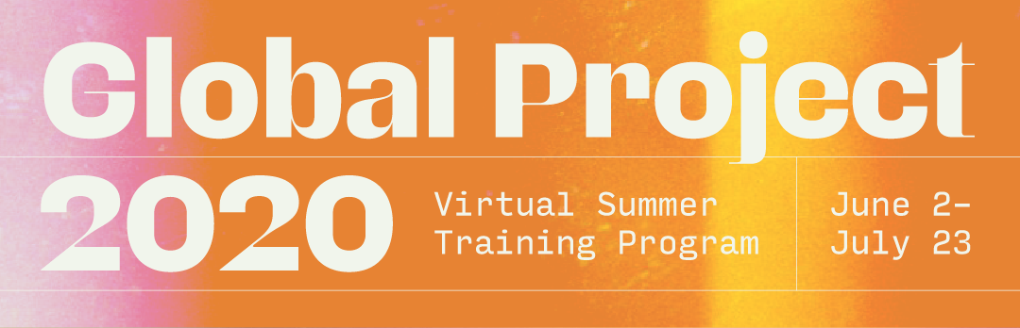

Did your summer just get upended? Reclaim it.

With COVID-19 shaking our world, many of your summer plans have been impacted. But that doesn’t mean we should give up. We will reclaim. We will redeem. We won’t be shaken.

This is the summer to change eternity.

Global Project 2020 is a multi-ministry virtual summer training program that students from around the world are joining to deepen their understanding of evangelism, disciple-making, and mission mobilization.

Components to Global Project:

Global Gathering — 2 hrs per week
Join students around the globe each Tuesday to hear from incredible spiritual leaders and break up into discussion groups afterwards to discuss and pray with students from other campuses around the nation/world. We will offer multiple live sessions each Tuesday to allow different time zones to have discussion groups.

Discipleship Groups — 2 hrs per week
Dive deep each week with your D-Group for bible study, book discussion of The Fuel and the Flame (updated student edition to be released soon), scripture memory review, accountability and prayer. D-Groups will be groups of 4 to 6, and may meet in person once social distancing guidelines are loosened.

Outreach — 1 hr per week
Training without application is never a good thing, so each participant will be expected to recruit 4 or more of their friends to join them virtually or in person to do one of the following:
- Evangelism: Recruiting 4+ friends to go through an evangelistic discovery Bible study
- Mobilization: Recruiting 4+ friends to go through an Xplore study learning about God’s heart for all nations
- Purity Group: Recruiting 4+ friends to go through Freedom Fight’s30 Day Challenge on sexual purity and resisting pornography
Prep Commitment — 2 to 3 hrs per week
- Bible Study: Participants will utilize the inductive Bible study method to prepare for your discussion on 2 Timothy each week
- Book Discussion: Read a few chapters of The Fuel and the Flame to discuss with your D-Groups
- Scripture Memory: Memorize a Scripture each week to be reviewed in your D-Groups

Spiritual Mentoring — 1 hr per week or two
Each D-group leader will have a 1-on-1 every other week (or weekly) with their participants.

Cost:

Global Project costs $50 per student, but BCM is offering a $25 discount code at registration. For anyone interested in the project, BCM will pay $25 of your registration cost thanks to a donation made by one of our alumni!

